**PJ 6 Report My Name: _Yaowei Lei_**

**A. The following is my Python source program:**

**// Please copy your source program into here from your Visual Studio IDE.**

**// Your code here must be in color. You must not show screen prints here.**

#------------------------------------------------------------------------------------------------------------.

# Author: Yaowei Lei

# Date: 11/15/2021

# Purpose: CS119-PJ6: Simple Calculator – to perform 6 mathematical operations for 2 numbers.

#------------------------------------------------------------------------------------------------------------.

n = 1 # line number for each separator line

print ("Welcome to the Simple Calculator of Yaowei Lei!")

print (n,"============================================================"); n+=1;

while True: # keep running forever. It must be stopped by a break inside the loop.

n1 = float(input("Enter your first number: ")) # input the first number as a float

operator = input("Enter your operator (@ to stop): ") # input a operator

n2 = float(input("Enter your second number: ")) # input the second number as a float

# calculate the result

if (operator == "/" or operator == "%") :

if (n2 == 0):

print("The second number cannot be zero!")

else :

if (operator == "/") :

print("Result: ", n1," / ", n2, " = ", n1/n2)

else :

print("Result: ", n1," % ", n2, " = ", n1%n2)

elif (operator == "+") :

print("Result: ", n1," + ", n2, " = ", n1+n2)

elif (operator == "-") :

print("Result: ", n1," - ", n2, " = ", n1-n2)

elif (operator == "*") :

print("Result: ", n1," * ", n2, " = ", n1*n2)

elif (operator == "**") :

print("Result: ", n1," ** ", n2, " = ", n1**n2)

elif (operator == "@") :

break

# exception: operator not valid

if (operator != "+" and operator != "-" and operator != "*" and operator != "/" and operator != "**" and operator != "%") :

print("Sorry, ",operator, " is not a valid operator!")

print (n,"============================================================"); n+=1;

print (n,"============================================================"); n+=1;

print("Thank you for playing this Simple Calculator of Yaowei Lei!")

print (n,"============================================================"); n+=1;

**B. The following is the console output of my 3 test runs:**

**// One way to copy the console output is to press Ctrl+Alt+PrtScn.**

**// Another way to copy is to use the snipping tool. To paste the image is to press Ctrl+v.**

**// The console display must not be too wide, otherwise it will be too hard to read once pasted.**

**// Please make sure your console is long enough to show all your output lines to be captured.**

**// Please copy your console output and paste into here:**

**Test Case #1:**

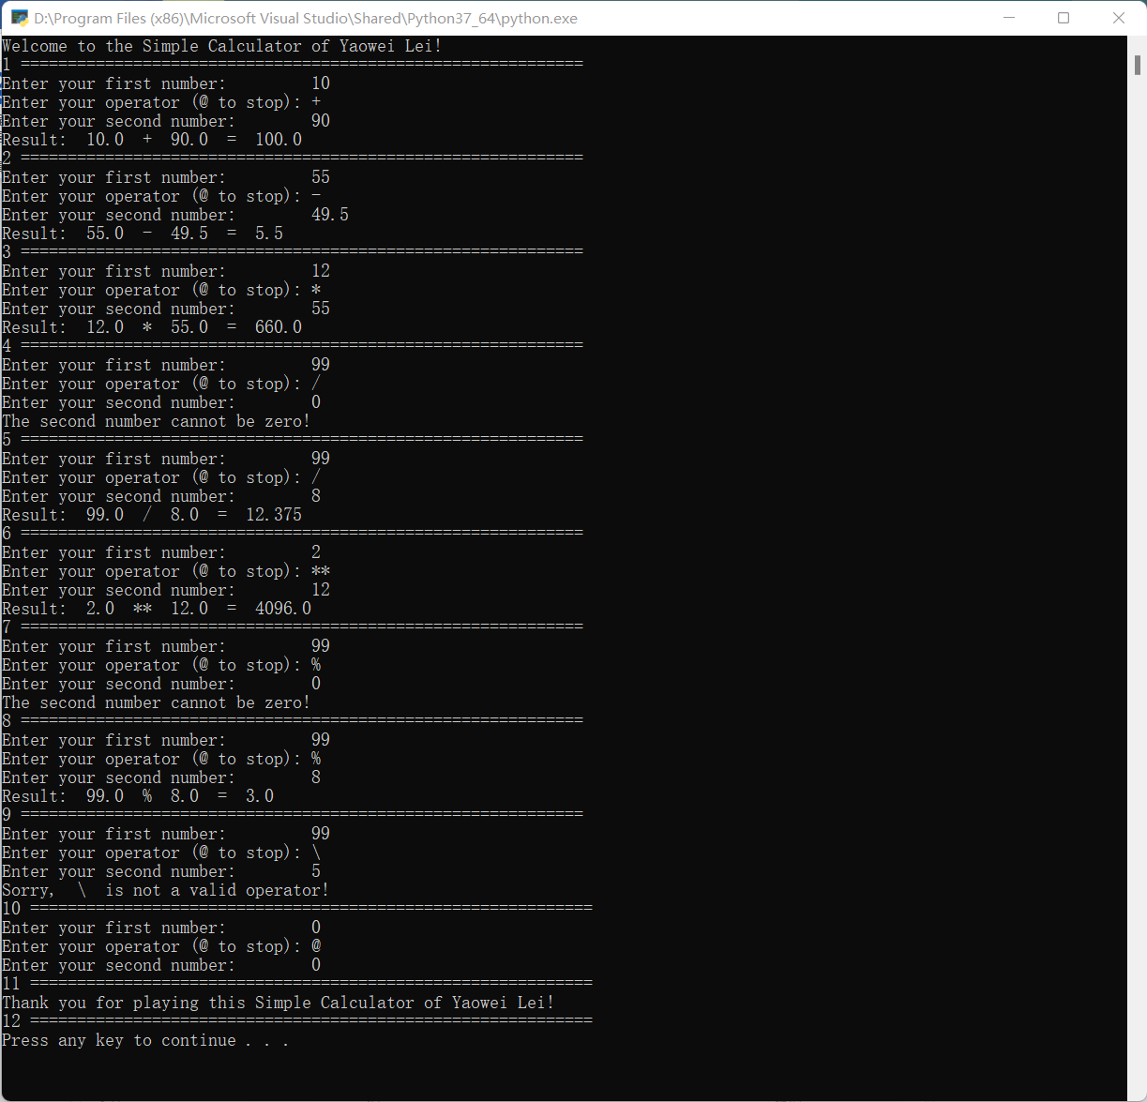

**Test Case #2:**

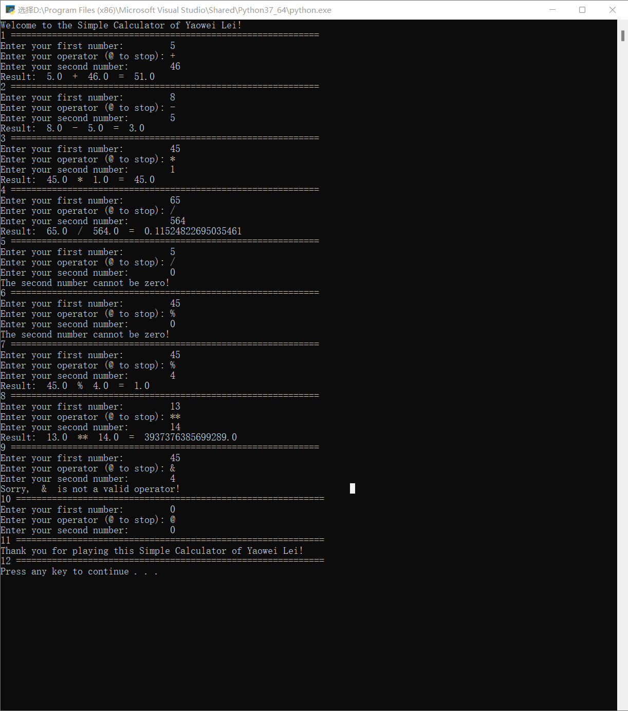

**Test Case #3:**

